**Lab#4**

**Object:** Write a program to print upper case alphabets from A to Z.

dosseg

.model small

.stack 100h

.data

.code

main proc

mov cl,26

mov dl,65

mov ah,2

l1:

int 21h

inc dl

loop l1

mov ah,4ch

int 21h

main endp

end main

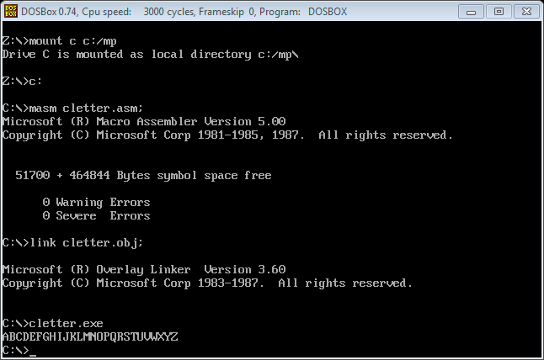

**Object:** Write a program to print lower case alphabets from a to z.

dosseg

.model small

.stack 100h

.data

.code

main proc

mov cl,26

mov dl,97

mov ah,2

l1:

int 21h

inc dl

loop l1

mov ah,4ch

int 21h

main endp

end main

